Taipei Fine Arts Museum Press Release
FOR IMMEDIATE RELEASE
Media Contact | Yu-mei Sung (yumei-tfam@mail.taipei.gov.tw)  Tzu-chin Kao (tckao-tfam@mail.taipei.gov.tw)

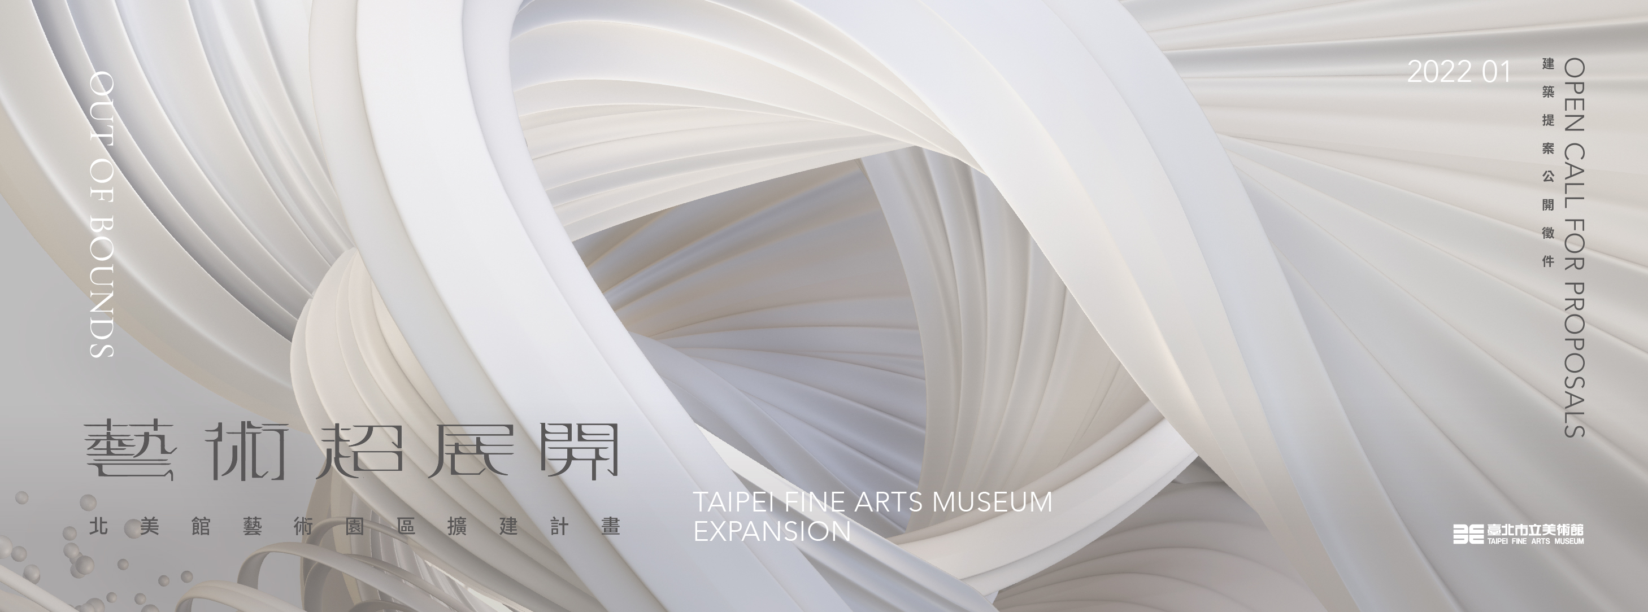

Launch of Out of Bounds: TFAM Expansion
Moving beyond imagination, expanding art into the unknown
Following several years of preparation, Taipei Fine Arts Museum announces the initiation of its two phase expansion project titled Out of Bounds: TFAM Expansion. Construction on a new collections vault will begin in October of this year, and an open call for architectural proposals of another new museum building will be launched in January of 2022. The Museum completed in 1983, together with the new collection storage area and second building that are expected to open in 2024 and 2026 respectively, will gradually form the Museum’s art complex, thus expanding Taiwan's contemporary art vista.
As Taiwan's first modern and contemporary art museum, over the past thirty-eight years the Museum has undergone several improvements and reorganizations to keep abreast of continuous transformations in the local and international art world. However, for many years now, its collection and exhibition spaces have been in urgent need of expansion to accommodate the several decades of growth experienced by Taiwan's rich and energetic art community. The Museum collections hold more than 5,300 important artworks and archives from Taiwan's modern period, as well as representative works by artists from Taiwan and abroad reflecting contemporary topics. However, with less than 8% of the current Museum's space allocated to the collection storage area, the space and its facilities are insufficient for the professional conservation, restoration, and research. Furthermore, although the museum archives vast collection of artworks presented in “Taiten” (Taiwan Art Exhibition), “Futen” (Taiwan Viceroy Art Exhibition) and other Taiwanese art assets, lack of space has made permanent exhibits impossible. On the other hand, the existing exhibition venues cannot accommodate the trend towards international art and cultural development in Taipei. Therefore, with the support of the Taipei City Government, the Museum began planning for expansion in order to facilitate Taiwanese art in comprehensive dimensions, and in recent years has taken decisive steps to accomplish this goal.
The new collections vault will consist of two basement levels under the existing Museum parking lot. In addition to the ease with which this new structure can be integrated with the current collection storage area, its placement underground will provide energy savings and resistance to natural shocks. The collections will be stored in separate areas equipped with specific environmental controls to provide suitable and stable safekeeping for each work. By building this new collection storage facility, the Museum will actively promote research and conservation education, as well as advance the protection of Taiwan’s rich artistic and cultural assets. The new structure's ground floor, in addition to providing space for necessary museum operations, will harmonize with the Museum's existing architecture and landscape design while providing different rest areas for the public. Also, the integration of the existing and new collection storage area will extend the area on the east side of the Museum's entrance plaza toward the south, thus leaving some flexibility for the next step of expansion and providing a more convenient visitor experience.
In the second phase of the Museum expansion, a new exhibition building will be situated under the Taipei Expo Park area to become Taiwan's first underground museum. The ground level will include a garden where art and nature commingle, establishing a new urban landmark for art education and public recreation. Responding to contemporary art's dynamics, the new building will include black boxes and other galleries that are fully equipped and prepared for future technological renewal, and will be dedicated to facilitating interdisciplinary collaboration, systematic research, and the creation of new art methodologies. Furthermore, an interactive learning space will be included, aiming to be an incubator of innovative arts as well as a hub of art education for future generations. Once the expansion completes, the main building will be positioned as a strategic center for research on the history of Taiwanese art, with permanent and curated exhibitions of historically significant Taiwanese art from the collection on view. These exhibitions will cast aside static, traditional display methods to offer fresh interpretations and contemporary perspectives. Bid specifications and requirements for the new Museum architecture will be made public before November. Construction proposals are expected to be publicly solicited in January of next year (2022).
From white cubes to black boxes, from modernist architecture to subterranean and invisible buildings, TFAM Expansion not only subverts fixed ideas of building expansion, but also makes clear the Museum's pioneering and comprehensive move toward hybrid and unknown art. As an institution that is both historical and contemporary, the future Taipei Fine Arts Museum art complex will drive forward a spectrum of new art expression based on the modern and contemporary. Furthermore, looking back from today's perspective, the Museum has extended the concept of multiperspectivity in history by listening to different narratives. A forward-looking vision creates a container that can hold the unknown and nourish a diverse and creative environment. The Museum expects to bring in professionals from a wide variety of fields, actively explore different practices, gradually construct new methodologies, and collaboratively expand art into the unknown while becoming an important hub driving the development of Asian art.
For more information, please refer to: http://expansion.tfam.museum

